GOVERNMENT ENGINEERING COLLEGE, THRISSUR

# **FACE BASED ATTENDANCE SYSTEM**

SUBMITTED BY

AHAMMED SHIBINSHA K K

*Student Id. TCR21CS003*

Mohamed Mashood

*Student Id. TCR21CS039*

Bassam Elachola

*Student Id. TCR21CS017*

## Rohan Mistry

*Student Id. TCR21CS055*

PROJECT GUIDE

## PANCHAMI V U

29FEBRUARY 2024

# DECLARATION OF AUTHORSHIP

We declare on our honour that the work presented in this dissertation, entitled “**FACE BASED ATTENDANCE SYSTEM**” using robust **Face Recognition Algorithm**,” is original and was carried out by **Ahammed Shibinsha K K**  (TCR21CS003), **Mohamed Mashood** (TCR21CS039), **Bassam Elachola** (TCR21CS017), and **Rohan Mistry** (TCR21CS055) under the supervision of Professor **PANCHAMI V U.**

*29 February 2024*

**Ahammed Shibinsha K K**

**Mohamed Mashood**

**Bassam Elachola**

**Rohan Mistry**

i

# ABSTRACT

The Face-Based Attendance System (FBAS) employs advanced face recognition algorithms for accurate and real-time identification. This report outlines the development and implementation of FBAS, focusing on its contactless, efficient, and secure attendance tracking. The system integrates cutting-edge face recognition technologies, user-friendly interfaces, and privacy measures. It eliminates traditional methods, offering a seamless experience and improving overall attendance management. The report highlights ethical considerations, legal compliance, and the system's adaptability to diverse environments, emphasizing its impact on modernizing attendance tracking.

ii

# CONTENTS

|  |  |
| --- | --- |
| **Contents** | **iii** |
| **List of Figures** | **1** |
| **1 Introduction** | **2** |
| **2**  **Face-Based Attendance System** | **3** |
| 2.1 Background. . . . . . . . . . . . . . . . . . . . . . . . . . . . . | 3 |
| 2.2 Formal Definition of Problem . . . . . . . . . . . . . . . . . . . | 4 |
| 2.3 Illustration of Face-Based Attendance System . .. . . . . . . . . . . . . . . . . | 4 |
| 2.4 Potential Users of Face-Based Attendance System. . . . . . . . . . . . . . . | 5 |
| 2.5 Estimated user base after two years . . . . . . . . . . . . . . . . | 5 |
| **3 Figures** | **6** |
| 3.1 Side-by-Side Figures . . . . . . . . . . . . . . . . . . . . . . . . | 6 |
| **4 Tables** | **8** |
| 4.1 Tabular Environment for Face-Based Attendance System. . . . .. . . . . . . . . | 8 |
| 4.2 Tabularx Environment for Face-Based Attendance System. . . . . . . . . . . . | 8 |
| 4.3 Longtable Environment for Face-Based Attendance System . . . . . . . . . . . | 9 |
| 4.4 Complex Tables in the Context of Face-Based Attendance System . . . . . | 10 |
| **5 Lists** | **12** |
| **6 Code Listings** | **14** |
| **7 Conclusion**  **Appendices** | **17** |
| **A Appendix A** | **23** |

iii

# LIST OF FIGURES

2.1 Basic face detection using OpenCV . . . . . . . . . . . . . . . . . . .. . . . . . . . 3

2.2 Workflow Diagram . . . . . . . . . . . . . . . . . . . . . . . . . . . . . . . . . . . . . . . 4

1

1

# I**NTRODUCTION**

In the dynamic realms of education, corporate environments, and various public sectors, the conventional methods of attendance tracking are undergoing a transformative shift. The Face-Based Attendance System (FBAS) stands at the forefront of this evolution, introducing a paradigm shift in the way we manage and record attendance. Traditionally, attendance systems relied on manual inputs, swipe cards, or biometric identification, each presenting its own set of challenges—ranging from accuracy issues to concerns about data security.

The emergence of facial recognition technology offers a promising alternative, and FBAS capitalizes on this innovation to address the limitations of existing systems. By leveraging sophisticated algorithms grounded in computer vision and deep learning, FBAS provides a contactless, efficient, and secure means of uniquely identifying individuals and recording their attendance. This report embarks on a comprehensive exploration of FBAS, unraveling its technological intricacies, implementation strategies, ethical considerations, and the potential transformative impact it carries.

2

2

PROBLEM

## 2.1 Background

Attendance management, critical for educational institutions and professional organizations, is undergoing transformative evolution. Traditional methods, marked by manual sign-ins, swipe cards, and biometric systems, face persistent challenges like inaccuracies, physical interaction inconvenience, and susceptibility to fraud. The growing need for an advanced attendance tracking system, driven by technological evolution, leads to the exploration of innovative alternatives. The Face-Based Attendance System (FBAS) emerges as a beacon, promising to redefine attendance management with a contactless and precise method for user identification, presenting a paradigmatic advancement across diverse domains.

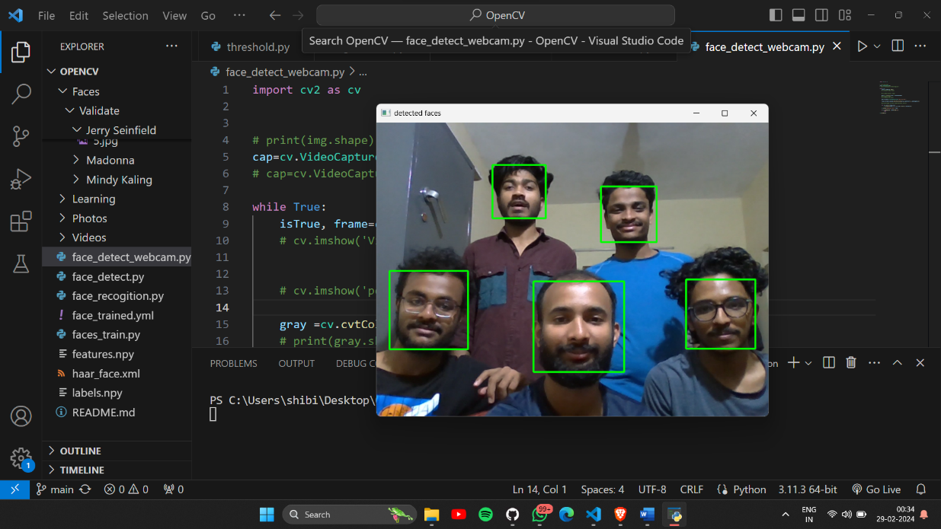

Figure 2.1:Face detection using OpenCV

3

4 *2. Problem*

## 2.2 Formal Definition of Problem

The conventional methods of attendance tracking fall short in providing a seamless integration into daily workflows, accurate identification, and data security. This discrepancy, coupled with the increasing need for a modernized approach to attendance management, has prompted the exploration of innovative solutions. In response, the Face-Based Attendance System (FBAS) emerges as a pioneering solution that rectifies the shortcomings of traditional methods, introducing a new era of efficiency and security. Leveraging advanced facial recognition technology for contactless and precise user identification, FBAS signifies a transformative leap in attendance management. In subsequent sections, we delve into the development, implementation, and potential impact of FBAS, highlighting its role in reshaping attendance tracking across diverse sectors. 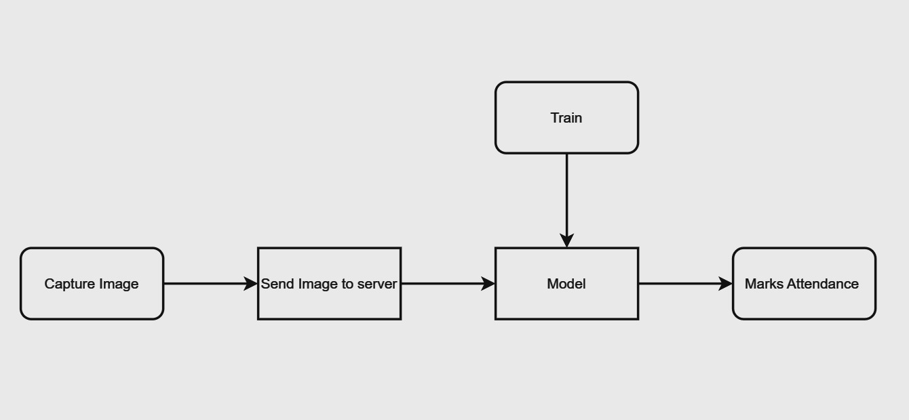

**Figure 2.2:** *Workflow diagram*

## 2.3 Illustration of Face-Based Attendance System

Consider a scenario where traditional attendance methods lead to inefficiencies, such as long queues during manual sign-ins, potential inaccuracies in biometric data, or the inconvenience of carrying physical cards. These scenarios highlight the need for a modernized attendance system that offers speed, accuracy, and user convenience, aligning with the dynamic pace of contemporary workflows. In response to these challenges, the Face-Based Attendance System (FBAS) emerges as a potential solution, promising not only to streamline attendance processes but also to introduce a seamless, contactless experience for users. By harnessing advanced facial recognition technology, FBAS addresses the shortcomings of traditional methods, presenting a reliable and efficient alternative.

*5 2.4. Potential Users*

## 2.4 Potential Users of Face-Based Attendance System

## FBAS caters to a broad spectrum of potential users, including educational institutions, corporate environments, and public facilities. Each of these domains faces unique challenges in attendance tracking, from large class sizes in schools to diverse workforce structures in corporate settings. A unified solution that addresses the specific needs of various users becomes imperative.

## 2.5 Estimated user base after two years

As technology adoption accelerates, it is anticipated that the user base for a Face-Based Attendance System will witness substantial growth. Projections indicate that within two years of implementation, FBAS could become an integral part of attendance management across a diverse range of sectors, impacting millions of users globally.

In the subsequent sections of this report, we will delve into the development and implementation of FBAS, exploring how it tackles these challenges and provides a forward-looking solution for attendance management in the modern era.